May 17, 2021

VIA E-MAIL TRANSMISSION
neal@menomoneeclub.org
Neal Bader
The Menomonee Club
1535 North Dayton Street
Chicago, IL 60654

In re: Real Estate Matters

Dear Neal:

On behalf of all of us at Georges & Synowiecki, Ltd., a certified women-owned firm, we are delighted to have the opportunity to represent The Menomonee Club in connection with real estate matters.

I will be the lawyer at the firm with the primary responsibility for the representation, and I will manage this engagement. We have agreed to handle this matter on a pro bono basis with The Menomonee Club being responsible for costs that will be incurred in this matter.

If the terms stated herein are satisfactory, please indicate your consent by signing this letter and returning it to me.

I very much look forward to working with you.

Very truly yours,

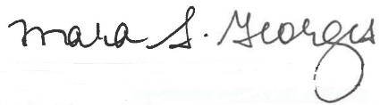

Mara S. Georges

MSG:mcs
Enclosure

May 17, 2021
Page Two

This letter and the Terms of Engagement are agreed to:

The Menomonee Club

By: ________________________________

Name: ______________________________

Title: _______________________________

Dated: ______________________________

